Test Queries for Functionality

1. To Log in

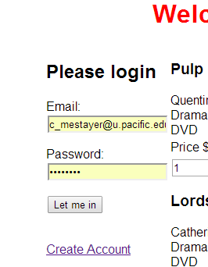

To log in, fill in info and click ‘let me in’

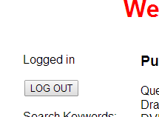

To log out, click ‘LOG OUT’

1. To create an account, click ‘Create Account’

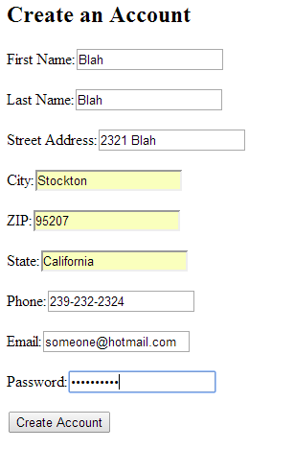

Fill in required info and click ‘Create Account’. If email already exists, then the account will not be created. If account is created successfully, then you will be taken back to the store page.

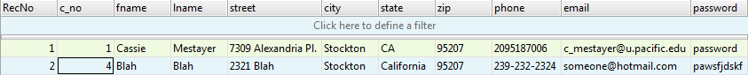

1. To add movie to cart, click ‘Add To Cart’ and specify the quantity if you want to.

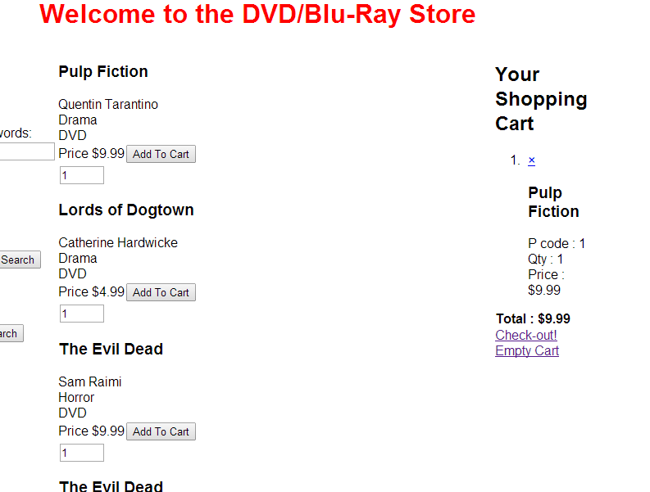

The ‘x’ in shopping cart will delete the item from the cart and ‘Empty Cart’ will empty the whole cart.

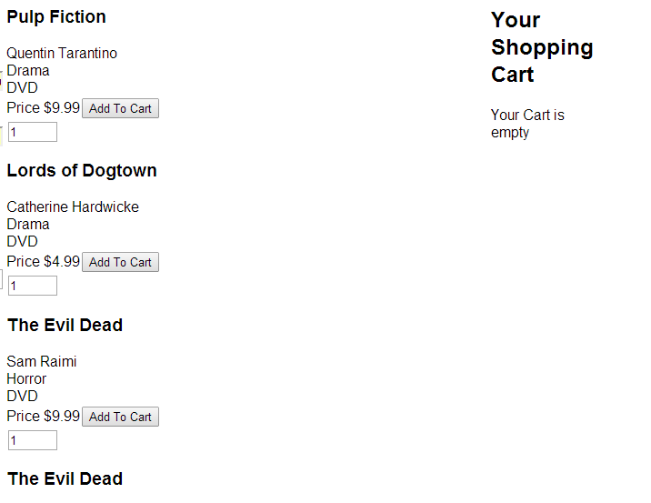

1. Search by Keyword, click ‘Search’

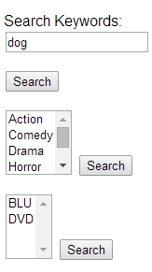

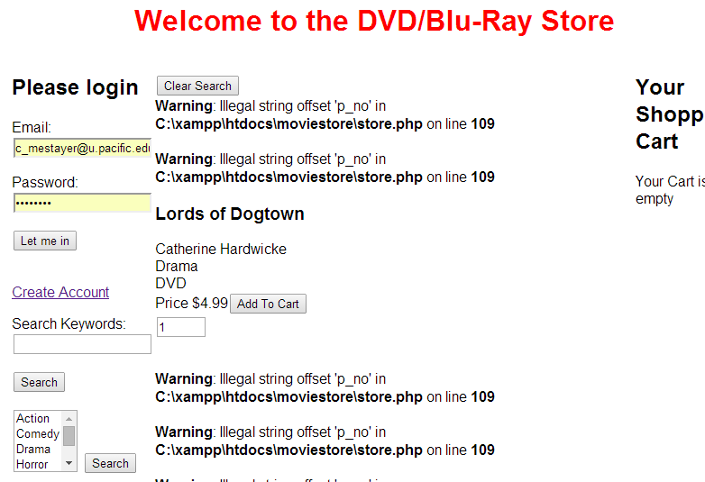

1. Clicking ‘Check-out!’ will take you to a page that makes sure you are logged in to purchase

